Encouraging self-study outside class by incorporating high-stakes writing
Appendix 1: Questionnaire responses
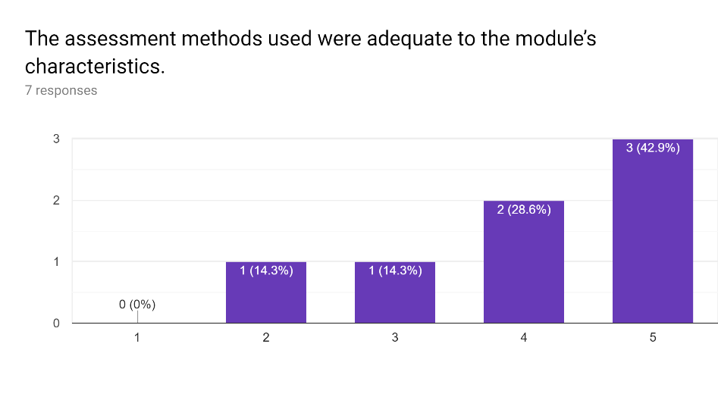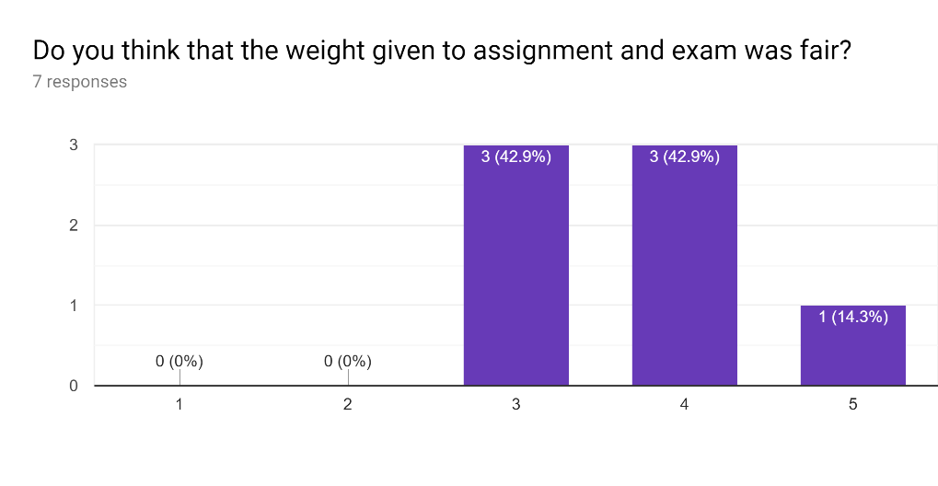
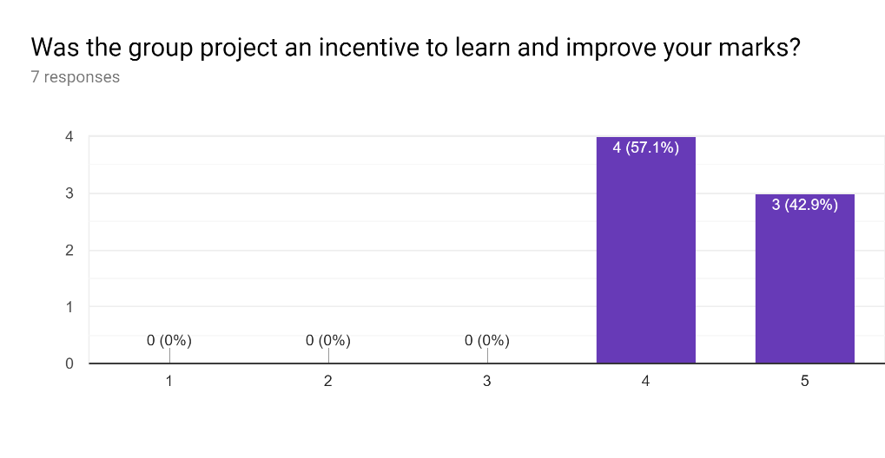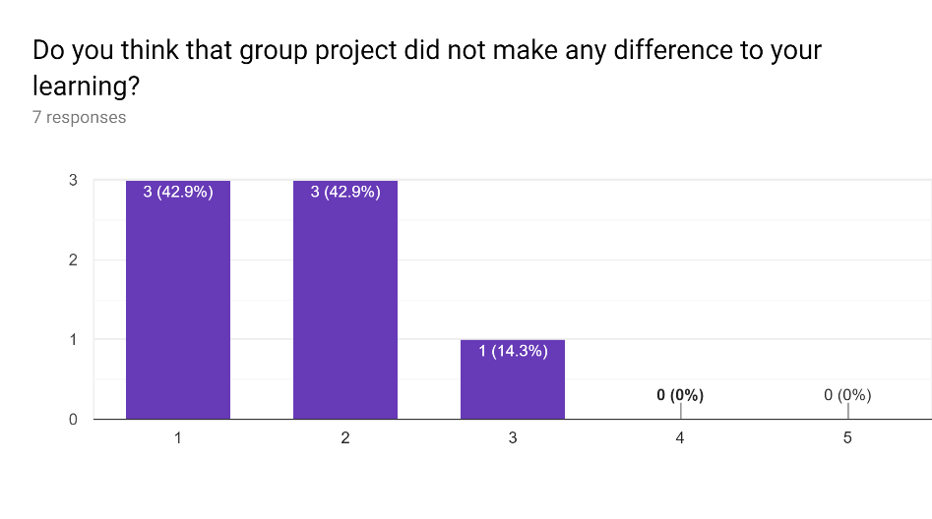
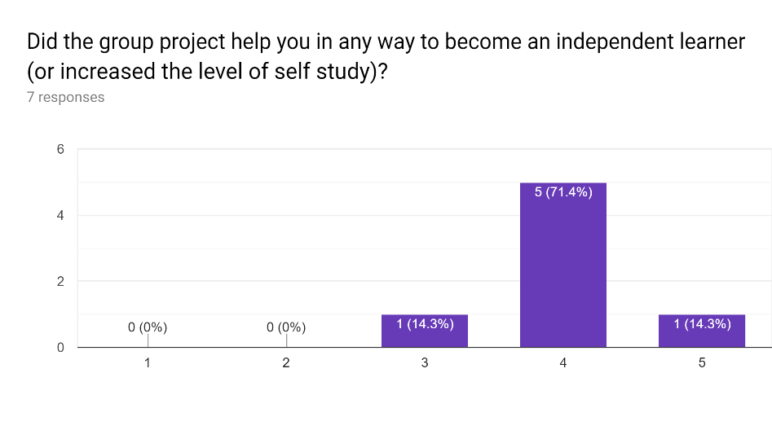
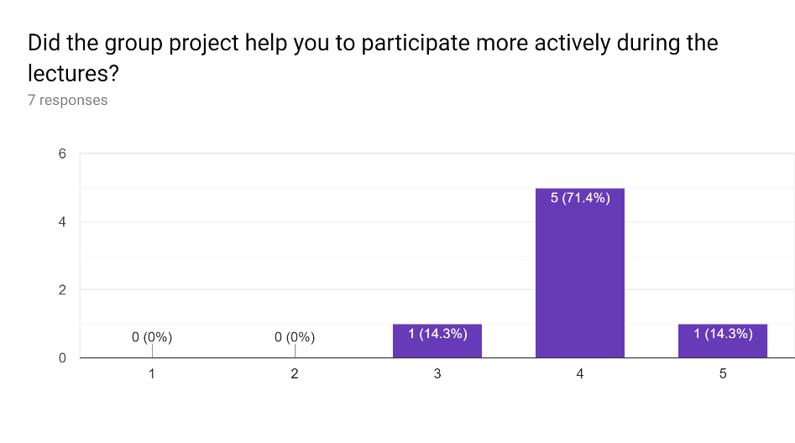
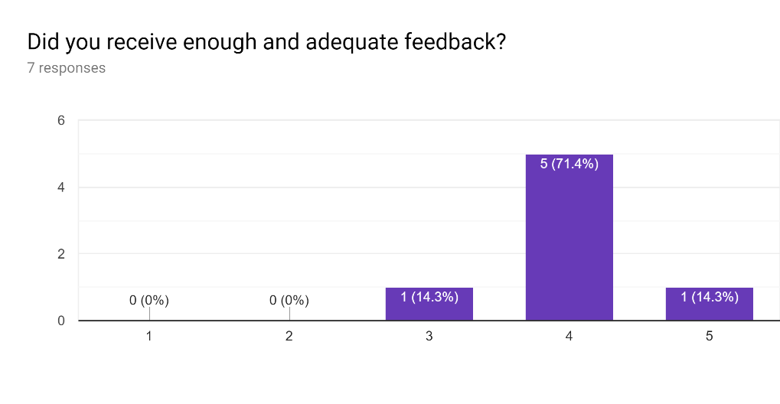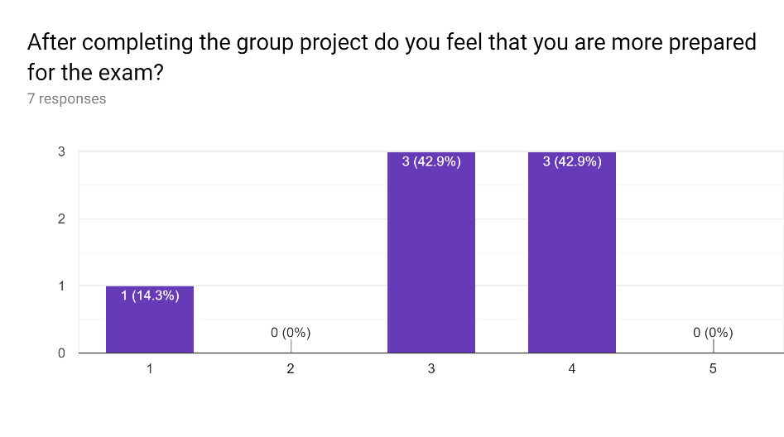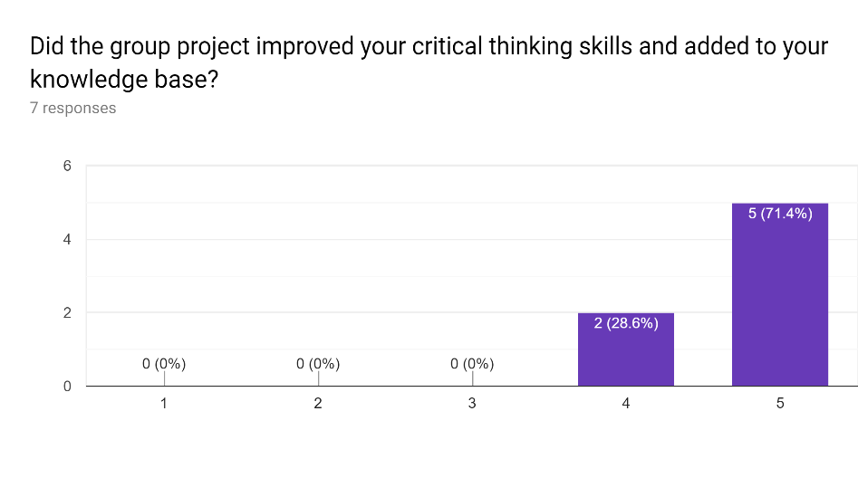
Student response to the open-ended question:
"I think the discussant role isn't really effective. Some just ask question just for the sake of asking to get marks. Only one or two students (discussant) that would have the will power/diligence to review the slide/journals that will be presenting beforehand. Instead I think, it's better if the role is reversed. Instead the discussant is the one asking question, make him the one answering question from presenter or summarising it."

